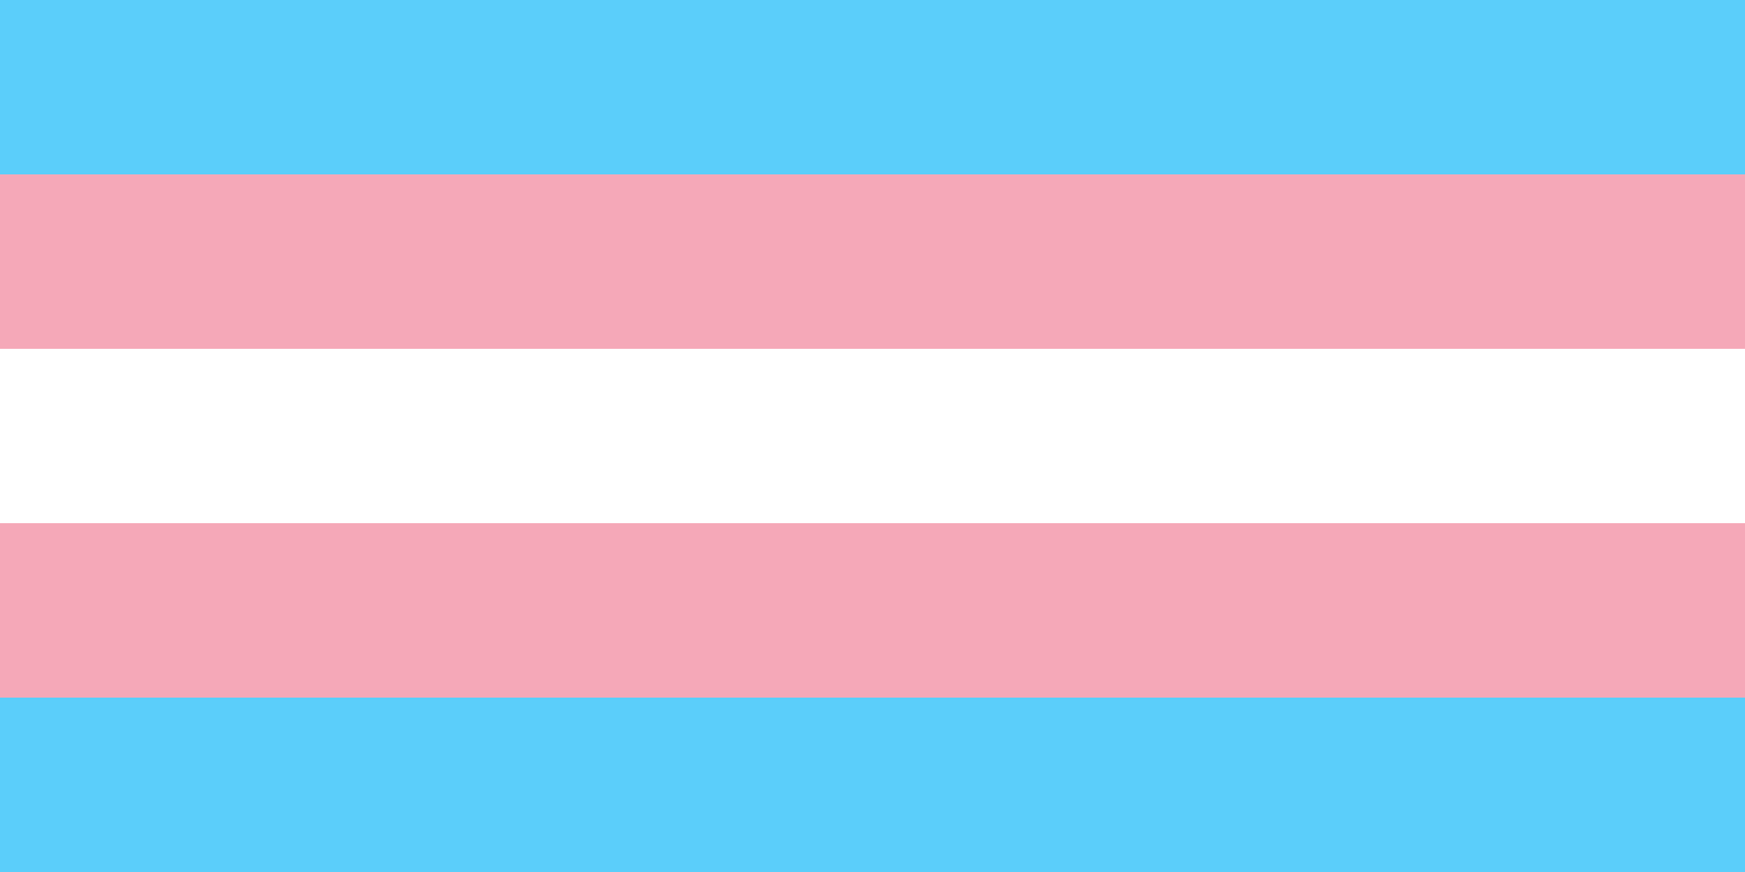

* Brought to you by Spectrum

**A presentation on transgender identities and experiences followed by an open discussion and Q&A.**

TRANS 101

Tuesday November 18th 7:30pm-8:30pm

Lowry 120